Scotch on the Rocks

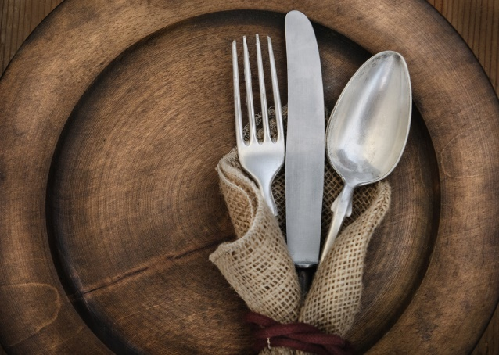

Menu
Options

Our talented cooks, Cherry and Elvis, know a wide range of recipes and are always willing to try new ones! Please let them know any dietary restrictions or preferences you may have so they can accommodate your requests.

Please confirm meal times. Usual meal times are:
Breakfast 8-10am, Lunch 12-3pm, Dinner 6-9pm
Breakfast
Coffee, Tea, Orange Juice, Fruit Platters and Cereals
can be served daily.

Standard Breakfast: served with toast & jam, bacon or sausages
Porridge - oats, cream of wheat, cornmeal, banana
Eggs - scrambled, fried, boiled, poached
Omelets - cheese, tomato, mushroom, ham, callaloo
Pancakes or Waffles
French Toast
Baked beans with Sausages

Jamaican Breakfast: served with boiled or fried dumplings, breadfruit, yam, sweet potato or green bananas
Ackee & Saltfish - Jamaica’s National Dish
Callaloo & Saltfish
Mackerel Rundown
Corned Beef & Cabbage
Chicken Livers

Light Fare for Lunch or Dinner
served with garlic bread, rolls, bammy, festival,
french fries or salad

Crab Backs
Shrimp Cocktail
Pepper Shrimps
Escovitch Fish
Quiche - cheese, ham, tomato, ackee or callaloo
Jerk Chicken Pasta Salad
Tuna Nicoise Pasta Salad
Spaghetti & Meat Sauce / Meatballs
Macaroni & Cheese
Stir-Fry Noodles with Market Vegetables
Burgers - beef, chicken, fish
Hot Dogs

Soups Salads Sandwiches
Pumpkin Tossed Salad Chicken Salad
Red Peas Cabbage Tuna Melt
Pepper Pot Caesar Grilled Ham & Cheese
Fish Potato Bacon, Lettuce & Tomato
Lobster Chowder Lobster, Tuna, Shrimp or Chicken Peanut Butter & Jelly
Lunch or Dinner Meals
Soup and/or Salad can be included in meals

Meats: can be jerked, curried, fried, grilled, fricassee, stewed or baked
Chicken Lamb - leg or chops
Turkey Fish - mahi mahi, snapper, kingfish, salmon
Beef - fillet or steaks Shrimp
Pork - leg, fillet, ribs or chops Lobster or Conch - in season
Jamaican Specialties: Oxtail, Stew Peas, Curried Goat

Starches : can be baked, boiled, fried, mashed or candied
Rice - white, brown, basmati, jasmine, rice & peas, pumpkin, callaloo
Irish Potato
Sweet Potato
Yam
Plantain
Corn Fritters

Vegetables: can be steamed, grilled or stir-fried
String beans Eggplant Cauliflower
Carrots Callaloo Pumpkin
Broccoli Corn Cho Cho
The ‘Befores’ and ‘Afters’
Hors d’oeuvres: served with crackers, chips, pita bread or dipping sauce
Coconut Chips
Solomon - a - Gundy with cream cheese
Smoked Marlin or Smoked Salmon with capers & cream cheese
Tomato Salsa
Curried Ackee
Salt Fish Fritters
Ceviche
Grilled Shrimp
Cheese Platter

Desserts: can be served with ice cream or whipped cream
Cakes Pies
Plain Apple
Chocolate Banana Cream Pie
Rum Key Lime
Pineapple Upside Down Lemon Meringue

Other Goodies
Coconut Custard Pavlova Brownies
Baked Bananas Bread Pudding Fruit Salad

